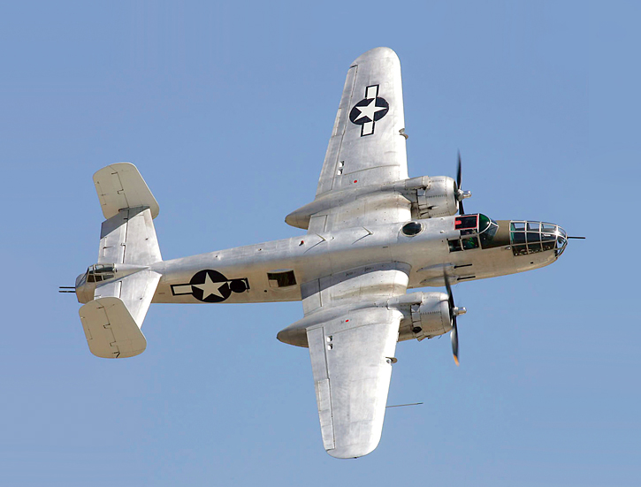

NORTH AMERICAN 8-25J MITCHELL

Best known as the bomber used by Jimmy Doolittle for his raid against Tokyo, Japan on April 18, 1942, the North American B-25 Mitchell became the backbone of the U.S. Army Air Force medium bomber campaigns during WWII.

Along with its counterparts, the Martin B-26 Marauder and the Douglas A-26 Invader, the B-25 performed up to and beyond its original design expectations. During the war, B-25s served in both the European and Pacific Theaters of Operations flying a wide variety of missions, including medium and low altitude bombing overland and anti-ship operations at sea. Very heavily armed for both defensive and offensive purposes, the B-25 could be fitted with as many as 18 heavy .50 caliber machineguns or a 75mm cannon and up to 14 machineguns, thus turning the bomber into a very formidable gun platform for strafing missions against shipping and ground targets, including strong fortifications and armored units.

During WWII, North American Aviation produced over 10,000 Mitchell bombers in a total of 10 major variants at plants in Inglewood, California and Kansas City, Kansas. In addition to service with the U.S. Army Air Force, those bombers were also used to good effect by the U.S. Navy and Marine Corps and the air forces of 17 foreign countries. The last operational B-25 was finally retired from the U.S. Air Force inventory in January 1959.
Planes of Fame Air Museum - Where Aviation History Takes Flight!
14998 Cal Aero Drive, Chino, California 91710 - phone: 909-597-7576 – fax: 909-597-4755
www.planesoffame.org - A nonprofit 501 (c)(3) organization - Tax I.D. #95-6092771
NORTH AMERICAN 8-25J MITCHELL (con’t)

Carrying the serial number 44-30423, Planes of Fame Air Museum's North American B-25J Mitchell was built in Kansas City in 1944. It served with the U.S. Air Force until the late 1950s when it was put up for disposal at Davis- Monthan AFB, Arizona. Purchased by a private owner from Sacramento, California, the Mitchell was finally obtained by Planes of Fame Air Museum in the early 1960s and has been kept in flying condition since then. It regularly appears at airshows throughout the southwest and is frequently used for movie and television projects, both as a camera platform and as a subject for various photo projects.

To learn more, please visit www.planesoffame.org or visit us on Facebook.

Planes of Fame Air Museum - Where Aviation History Takes Flight!
14998 Cal Aero Drive, Chino, California 91710 - phone: 909-597-7576 – fax: 909-597-4755
www.planesoffame.org - A nonprofit 501 (c)(3) organization - Tax I.D. #95-6092771

