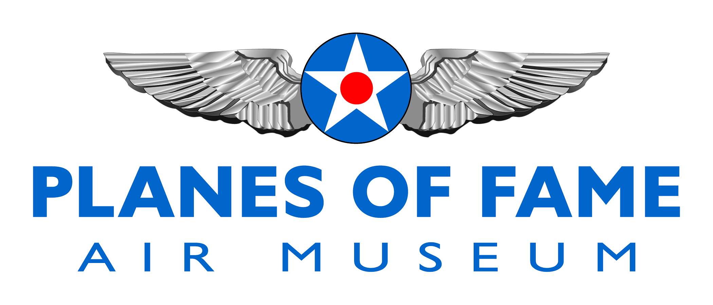
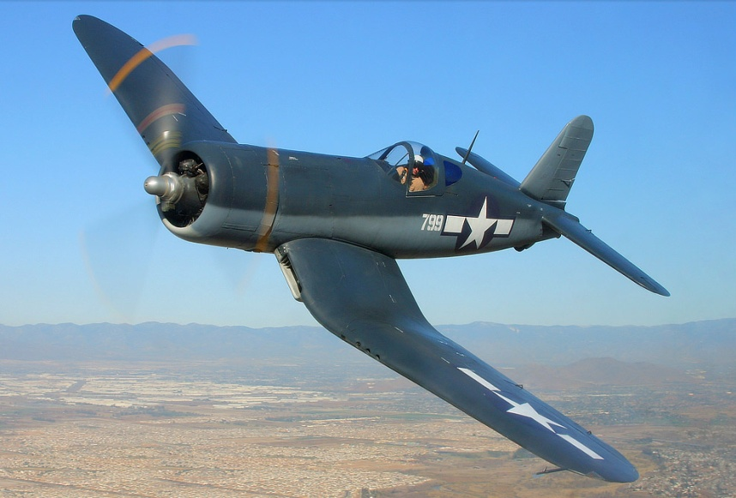

VOUGHT F4U-l CORSAIR

Conceived in early 1938 in response to a US Navy requirement for a high-speed, high altitude fighter, the prototype inverted gull-winged XF4U-1 Corsair first took to the air in May 1940 and immediately proved itself to be one of the fastest fighter aircraft in the world. In June 1941, the Navy issued the first production contract for the somewhat revised F4U-1 model and the basic design continued in production until January 1953, at which time over 12,800 Corsairs of all models had been built.

Although the Corsair (often known as the "Whistling Death" by the Japanese because of the noise that it made in high-speed flight, the "Bent-Winged Bird" by its crews because of its wing design or simply "Old Hose Nose" because of its very long nose) enjoyed an extremely long production run by the standards of its era, the aircraft, primarily because of economic considerations, did not become as popular on the civil register as some other fighters such as the North American P-51 Mustang. Nevertheless, there are still a few Corsairs airworthy around the world and, from time to time, racing versions of the big fighter have even bested the more numerous and streamlined highly modified Mustangs in unlimited air races.

One of the basically stock Corsairs still active is F4U-1 Bu No .17799 (civil registration NX83782), which belongs to Planes of Fame Air Museum at Chino Airport in Southern California. According to

Planes of Fame Air Museum - Were Warbirds Fly and Aviation History Lives
7000 Merrill Avenue #17, Chino, California 91710 - phone: 909-597-3722-fax: 909-597-4755
www.planesoffame.org - A nonprofit 501 (c)(3) organization - Tax I.D. #95-6092771

VOUGHT F4U-l CORSAIR (con’t)

the limited information that the Museum has concerning the history of this particular aircraft, it first arrived at San Diego, California in August 1943 and was assigned to a Navy fighter squadron (VF84) in December of the same year. In January 1944, the aircraft was reassigned to VBF-14 (a fighter-bomber unit) until being transferred to VBF-98 in February 1945. Between April and June 1945, the Corsair served with a carrier air support unit (CASU-33) before being withdrawn from active service on August 31, 1945. From the sketchy records available, it appears that the aircraft actually saw combat service in the Pacific with VBF-14 and/or VBF-98.

After being sold on the surplus market, 17799 wound up in use as a Hollywood movie prop at the Twentieth Century Fox Studios until it was eventually acquired by Planes of Fame Air Museum in 1970. Obtained from the studio without an engine, engine cowling or tail surfaces, the Corsair (temporarily fitted with an F4U-4 engine cowling) did not go on static display at Chino until 1973.

In 1976, Jim Maloney and Steve Hinton restored the Corsair to flying condition in basically a stock F4U-l configuration. The primary changes to the aircraft were confined to covering the outer wing surfaces with metal (early models of the Corsair had fabric-covered outer wing panels aft of the spar) and using a Pratt & Whitney R-2800 engine with a single-stage supercharger from a Douglas A-26 Invader bomber in place of the two-stage, two-speed, supercharged R-2800-8 engine that was more common to the early model Corsair fighters. Since the Museum's aircraft seldom fly above 10,000 ft., high-altitude performance was not very important and, because it does not require intercoolers, the bomber engine allowed for a significant weight reduction. In all, the restored Corsair is about 700lb lighter than a stock aircraft. Although it has about the same top speed at low altitude as a standard F4U-l, the Museum's Corsair has a better rate of climb at low altitudes and a shorter take-off roll.

Since restoration, the Corsair has taken part in numerous air shows and flown in a variety of Hollywood productions including the Baa Baa Blacksheep television series, Airwolf, Space, an IMAX film and an ABC Wide world of flying video.

To learn more, please visit www.planesoffame.org or visit us on Facebook.
Planes of Fame Air Museum - Were Warbirds Fly and Aviation History Lives
7000 Merrill Avenue #17, Chino, California 91710 - phone: 909-597-3722-fax: 909-597-4755
www.planesoffame.org - A nonprofit 501 (c)(3) organization - Tax I.D. #95-6092771

