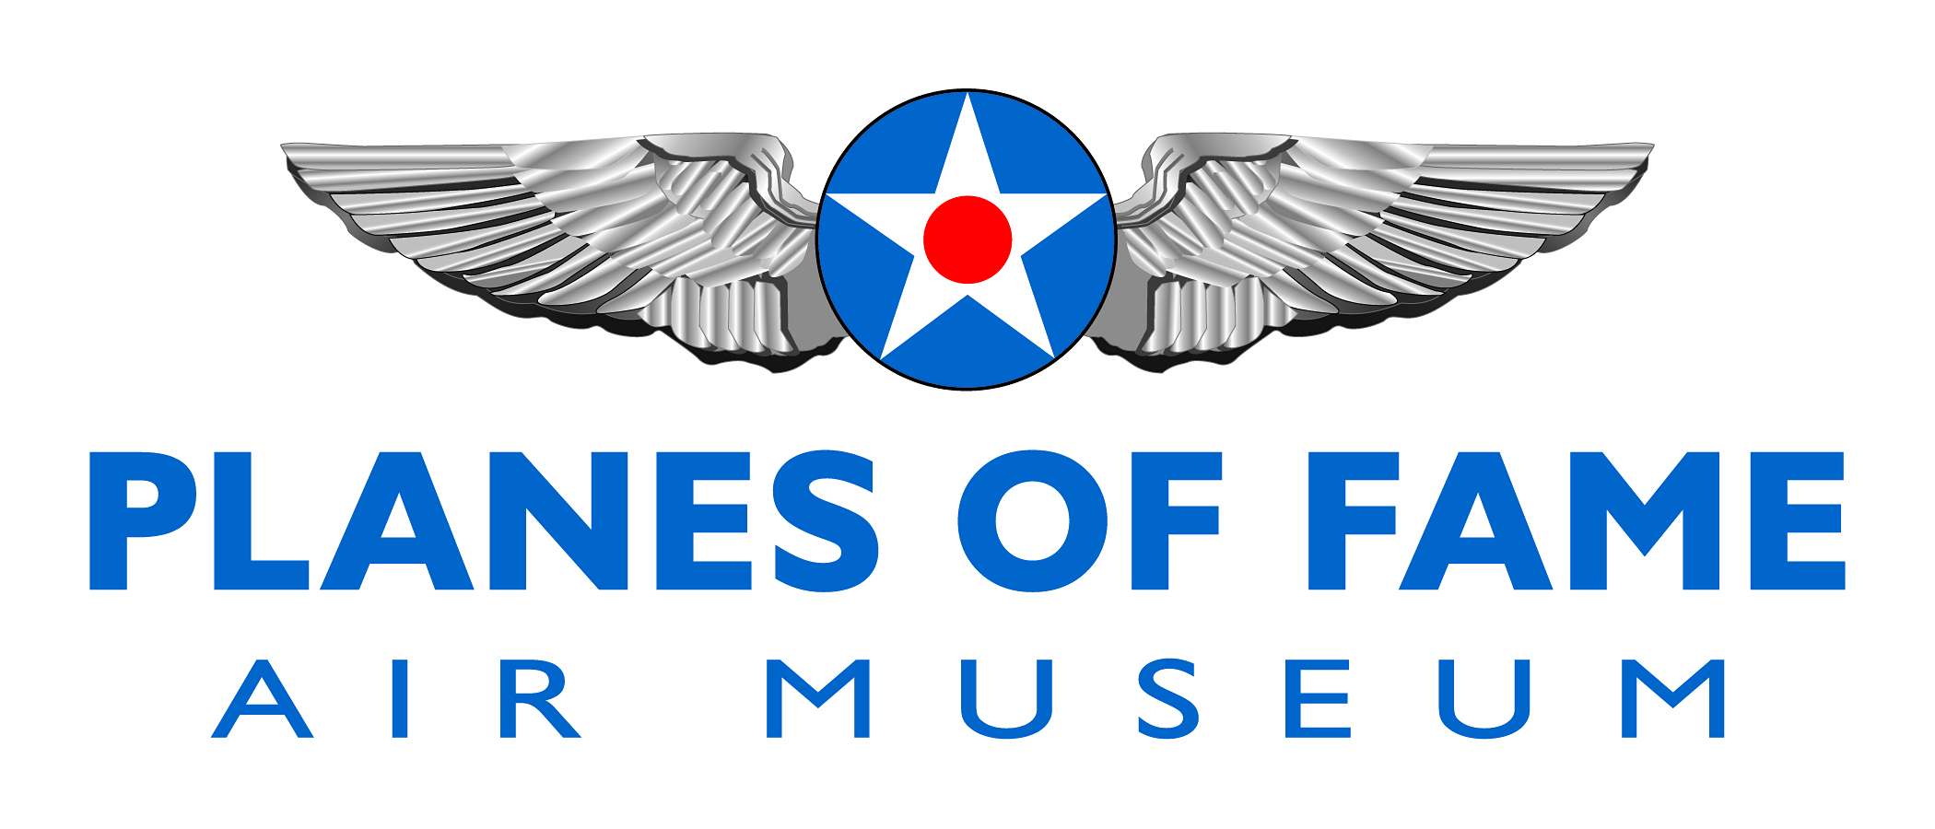

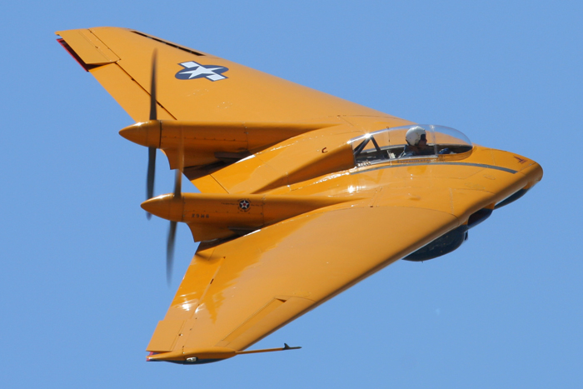

NORTHROP N9MB FLYING WING

The Northrop N9MB flying wing was the 4th in the N9M series of aircraft produced by Jack Northrop as test aircraft for the flying wing design. The N9MB at Planes of Fame is the only remaining airframe of the N9M series. The N9MB was carefully restored over a 13-year period and is in flight status today. This aircraft is flown regularly at the museum and other local airshows. This aircraft is the actual great-grandfather of the modern day B-2 Spirit flying wing heavy bomber.

When Northrop's Flying Wing bomber program was canceled, all remaining N-9M flight test aircraft, except for the final N-9MB, were scrapped. For more than three decades, it slowly deteriorated until the Chino, California Planes of Fame Air Museum acquired the aircraft in 1982 and began the labor intensive restoration process. For the next two decades, former Northrop employees and other skilled volunteers, slowly returned the N-9MB to its final flight configuration.[S] Since 2001, the yellow-and-blue Flying Wing has been exhibited, with flight demonstrations at several airshows every year.
To learn more, please visit www.planesoffame.org or visit us on Facebook.
Planes of Fame Air Museum - Where Aviation History Takes Flight!
14998 Cal Aero Drive, Chino, California 91710 - phone: 909-597-7576 – fax: 909-597-4755
www.planesoffame.org - A nonprofit 501 (c)(3) organization - Tax I.D. #95-6092771

