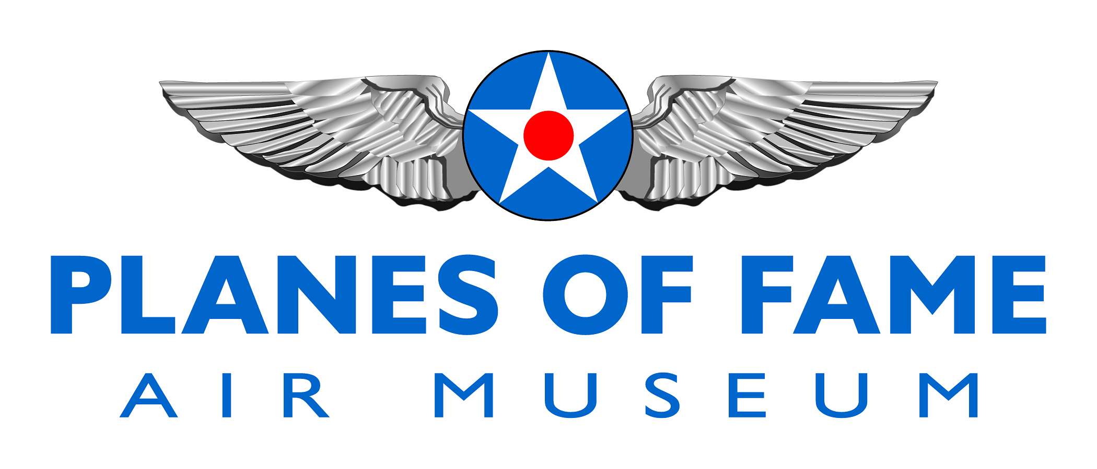
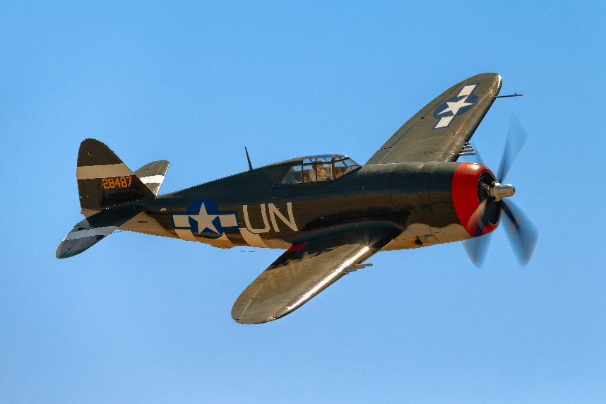

REPUBLIC P-47G THUNDERBOLT

A total of 15,660 P-47 Thunderbolts were produced for the US Army Air Corps during World War Two.

The P-47G was powered by a 2,300 h.p. Pratt and Whitney R-2800 18-cylinder radial air-cooled engine and could reach a top speed of 433 m.p.h. at an altitude of 30,000ft. The aircraft had a service ceiling of 40,000ft and a maximum climb rate of 2,750ft/min.

With an empty weight of 9,000lb, a normal loaded weight of 13,500lb and a maximum weight of 15,000lb, the Thunderbolt was the heaviest single-engined fighter of its day. It had a wingspan of 41ft, a length of 36ft and a height of nearly 15ft.

In 1952, Ed Maloney obtained the aircraft and stored it at his home with the intention of eventually displaying it in his projected air museum.

Steve Hinton’s Fighter Rebuilders crew, together with museum volunteer workers, began bringing the Thunderbolt up to flying condition again in early 1985.

Over the years, the P-47 has appeared in a number of different color schemes. During the war, it carried the standard Army Air Corps olive and grey camouflage scheme which was changed to a yellow and black finish when the aircraft was at Grand Central. when the Thunderbolt was finally restored to flying condition again, it reappeared in a very accurate paint scheme as 42-8487 Spirit of Atlantic City, N.J., Mahurin’s P-47D-5.
Planes of Fame Air Museum - Where Aviation History Takes Flight!
14998 Cal Aero Drive, Chino, California 91710 - phone: 909-597-7576 – fax: 909-597-4755
www.planesoffame.org - A nonprofit 501 (c)(3) organization - Tax I.D. #95-6092771
Carrying the civil registration NX3395G in very small characters, 42-25254 took to the air again after its latest restoration in mid-May 1985, just in time to make its debut in the Planes of Fame Air Museum’s sixth annual Planes of Fame Air Display at Chino Airport on May 18 and 19, 1985.

The P-47 Thunderbolt continues to perform at air shows in order to demonstrate and preserve aviation history, and honor Veterans.

To learn more, please visit www.planesoffame.org or visit us on Facebook.

Planes of Fame Air Museum - Where Aviation History Takes Flight!
14998 Cal Aero Drive, Chino, California 91710 - phone: 909-597-7576 – fax: 909-597-4755
www.planesoffame.org - A nonprofit 501 (c)(3) organization - Tax I.D. #95-6092771

