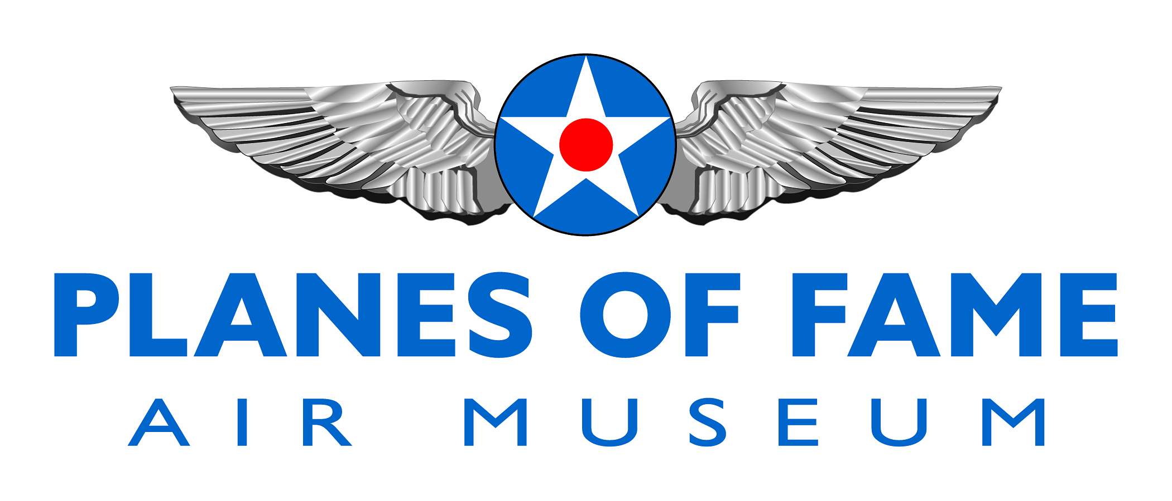
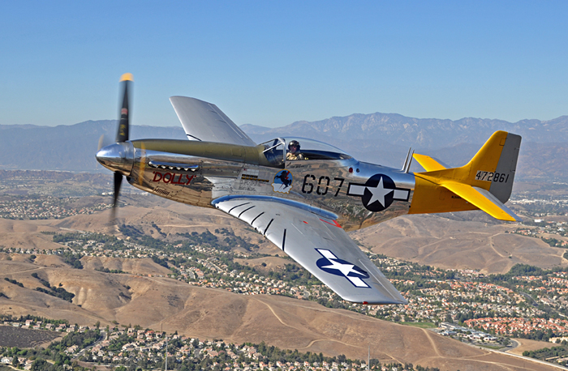

NORTH AMERICAN P-51D MUSTANG

Along with the Supermarine Spitfire, the North American P-51 Mustang is undoubtedly one of the most recognizable fighter planes to emerge from World War Two. Once it was fitted with the same type of engine -the Merlin- that powered its British counterpart, the Mustang went on to establish a reputation as one of the most effective all-round fighters of the war and certainly the best long-range escort fighter of its era.

Today, Mustangs are the most common type of warbird operating on the civil scene in the USA and may be viewed at virtually every air show in the country. Of all the Mustangs still flying, it is believed that P-51D-30-NT serial 45-11582 holds the record for continuous operation under the same ownership.

Mustang 45-11582 was manufactured at the North American Aviation plant in Dallas, Texas and delivered to the United States Army Air Corps on July 26, 1945. It was initially received by the 4121st Base Unit, Kelly Field, Texas and then assigned to the 31st Fighter Group, Turner AFB, Georgia. Re-designated the F-51D in July 1948 (with the formation of the independent United States Air Force, all USAF fighters were given the F for Fighter designation in place of the previous P for Pursuit), the Mustang went into Air National Guard service with the 155th Fighter Squadron, Memphis, Tennessee in March 1949 and was transferred to the 134th Fighter Squadron, Burlington, Vermont in January 1951.

Planes of Fame Air Museum - Where Aviation History Takes Flight!
14998 Cal Aero Drive, Chino, California 91710 - phone: 909-597-7576 – fax: 909-597-4755
www.planesoffame.org - A nonprofit 501 (c)(3) organization - Tax I.D. #95-6092771

NORTH AMERICAN P-51 MUSTANG (con’t)

In November 1952 the Mustang was assigned to the Air Defense Command's 37th Fighter Interceptor Squadron at Burlington, Vermont until being returned to ANG service again with the 167th Fighter Bomber Squadron, Kanawaha County, West Virginia in September 1953. Withdrawn from service in December 1956, the Mustang was transferred to the Sacramento, California Air Material Area where it was officially removed from the inventory and sold.

Ed Maloney purchased 45-11582 during the surplus sale which was held at McClellan AFB, California in November 1957. At that point the Mustang received the civil registration N5441V and became one of the star attractions in his growing museum collection which later came to be known as Planes of Fame Air Museum at Chino Airport in Southern California.

Maintained in flying condition since it was obtained by the Planes of Fame Air Museum, the Mustang has operated in a variety of paint schemes since 1957. In May of 2004, 'Spam Can' was repainted to resemble Major James Goodson's Mustang from the 336th Fighter Squadron. In May 2012, 'Spam Can' was repainted to resemble 'Dolly', J. J. Grant's P-51 from the 506th Fighter Group.

To learn more, please visit www.planesoffame.org or visit us on Facebook.

Planes of Fame Air Museum - Where Aviation History Takes Flight!
14998 Cal Aero Drive, Chino, California 91710 - phone: 909-597-7576 – fax: 909-597-4755
www.planesoffame.org - A nonprofit 501 (c)(3) organization - Tax I.D. #95-6092771

