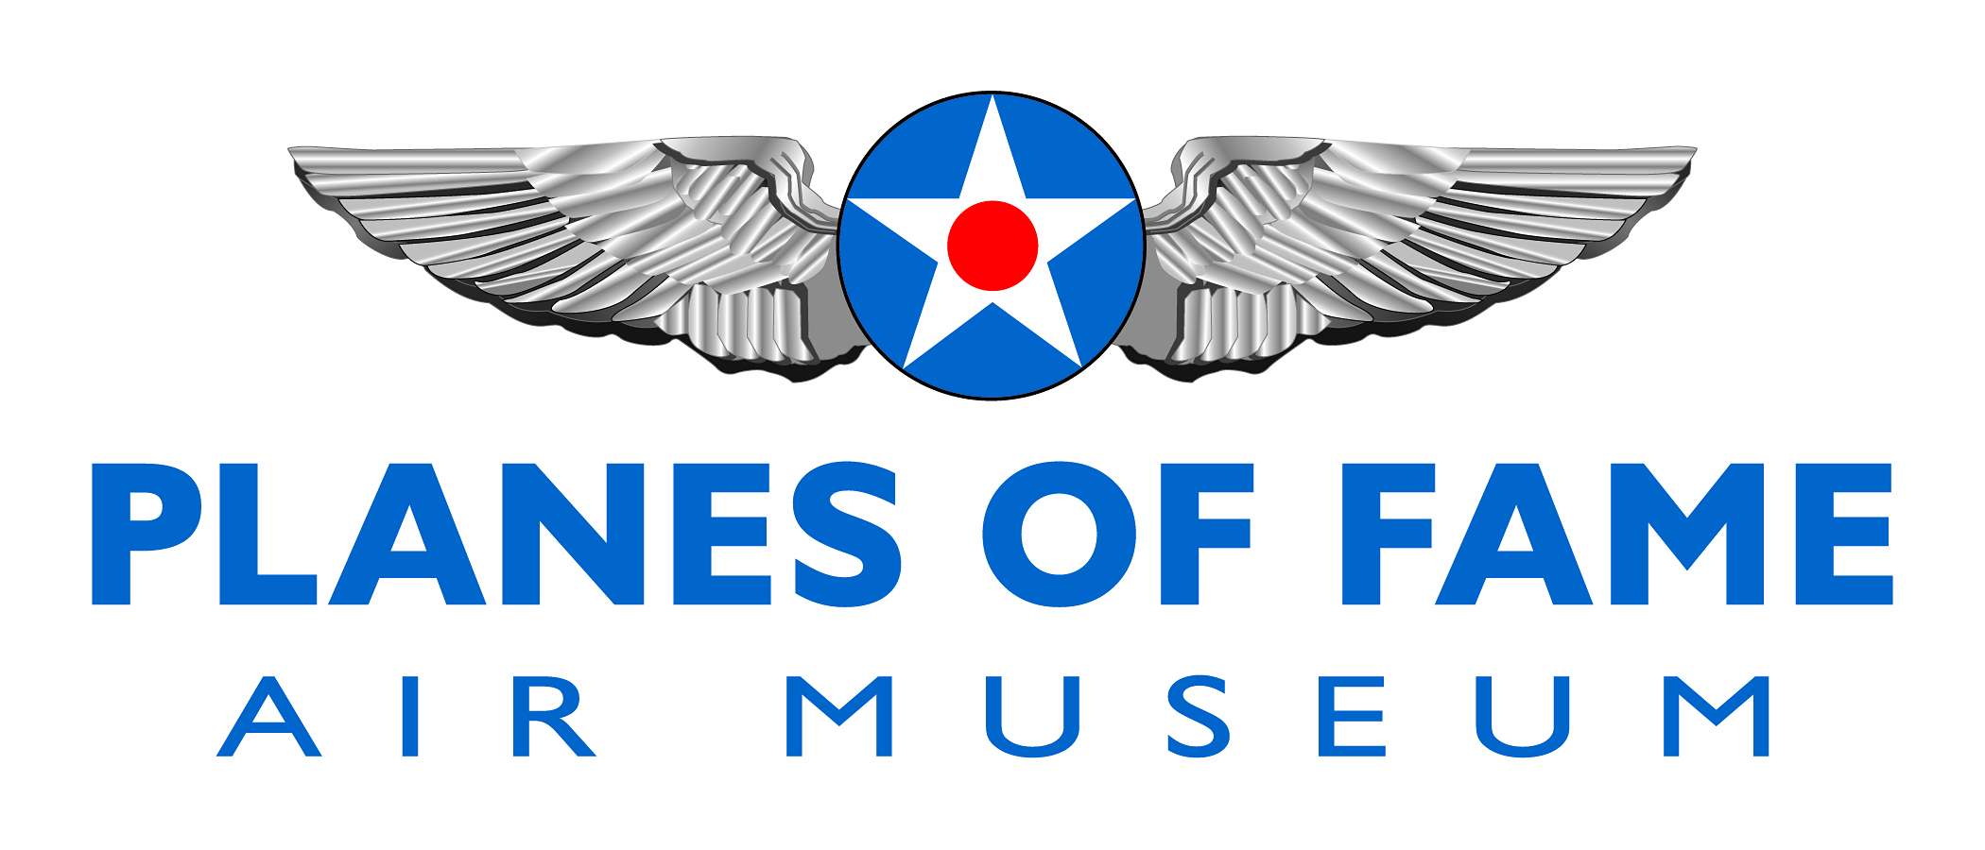

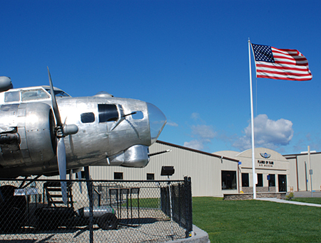

Planes of Fame Air Museum is a non-profit 501(c)(3) organization founded in 1957 by Ed Maloney. It is the mission of Planes of Fame Air Museum to preserve aviation history, inspire interest in aviation, educate the public and honor aviation pioneers and veterans.

The first aircraft Ed Maloney collected were stored in the backyard of his home as his wife Louise and four children looked on. In January, 1957 Ed Maloney took a major step in his preservation efforts by opening to the public a small museum in Claremont, California called simply 'The Air Museum'. Ed Maloney was determined not only to preserve historic aircraft but to keep them flying as well. Today Planes of Fame Air Museum operates two facilities: one at Chino Airport in Chino, CA and the other at Valle Grand Canyon Airport in Valle, AZ. We have over 130 historic aircraft on display as well as a hands on aviation learning center and theater.

To learn more, please visit www.planesoffame.org or visit us on Facebook.
Planes of Fame Air Museum - Were Warbirds Fly and Aviation History Lives
7000 Merrill Avenue #17, Chino, California 91710 - phone: 909-597-3722-fax: 909-597-4755
www.planesoffame.org - A nonprofit 501 (c)(3) organization - Tax I.D. #95-6092771

