Planes of Fame Airshow Press Release 2018

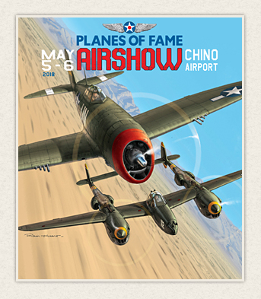
Planes of Fame Air Museum is proud to present the Planes of Fame Air Show on May 5-6, 2018. Featuring over 40 historic aircraft, including P-47 Thunderbolts, P-38 Lightnings and P-51 Mustangs flying for your enjoyment. We invite you to join us in honoring the history, contributions, and sacrifices of our Veterans.
Performers include: A-10 Thunderbolt and Heritage Flight; Sean D. Tucker Team Oracle Aerobatics; World's fastest piston engine aircraft P-51 Mustang Voodoo; N9MB Flying Wing Demo; Pacific, European, Korean & Vietnam Flight Displays, Sanders Sea Fury Aerobatics, Gregory 'Wired' Colyer T-33 Aerobatics and Rob Harrison the Tumbling Bear.
There will be a Kids Zone, static displays, food & vendors, and more!
In addition to many other fantastic airplanes that will be performing and on static display, there will be a special panel discussion with some of our honored Veterans. Follow our Planes of Fame Air show Facebook page to receive up to the minute news on Performers and attending Aircraft and Veterans!
Saturday and Sunday May 5-6, 2018; 8am - 4pm See all of your favorite airplanes fly!

SAVE $5 ORDER TICKETS ONLINE! (Hurry! Limited Time Offer)
Free Admission Kids 11 Years & Under, General $25 FREE PARKING! (Preferred Parking $17.50) FOR INFO AND TICKETS GO TO WWW.PLANESOFFAME.ORG

Planes of Fame Air Museum - Where Aviation History Takes Flight!
14998 Cal Aero Drive, Chino, California 91710 - phone: 909-597-7576 – fax: 909-597-4755
www.planesoffame.org - A nonprofit 501 (c)(3) organization - Tax I.D. #95-6092771

